**如何打开ADB调试**：

**How to open ADB debugging:**

1、将电脑和TV连接到同一个WiFi（局域网）

Connect the computer and TV to the same WiFi (LAN)

2、在TV的settings里面查看已连接WiFi的IP地址，见下文图一

Check the IP address of the connected WiFi in the TV settings, see Figure 1 below.

3、将ADB.rar压缩文件复制到电脑D盘

copy the ADB.rar compressed file to the computer D drive

4、解压此文件到当前目录（D盘根目录）

extract this file to the current directory (D disk root directory)

5、按住Win+R

press Win+R

6、输入cmd，回车

input cmd + Enter

7、输入d:回车

input d: + Enter

8、输入ADB回车

input ADB + Enter

9、输入adb connect 192.168.1.110:5555回车（192.168.1.110需要改成自己的IP地址，5555 为端口号）

input adb connect 192.168.1.110: 5555 + Enter (192.168.1.110 need to change to their own IP address, 5555 for the port number)

10、输入adb shell回车，进入ADB调试

input adb shell + Enter, enter ADB debugging

输入ls命令可检测ADB调试模式是否生效

input ls command to check whether the ADB debugging mode takes effect.

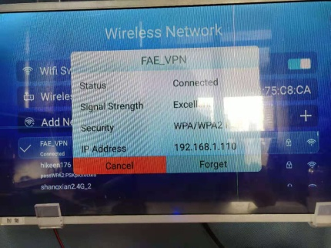(Picture 1)